2200030216 assertion testing junit testing

Out put  
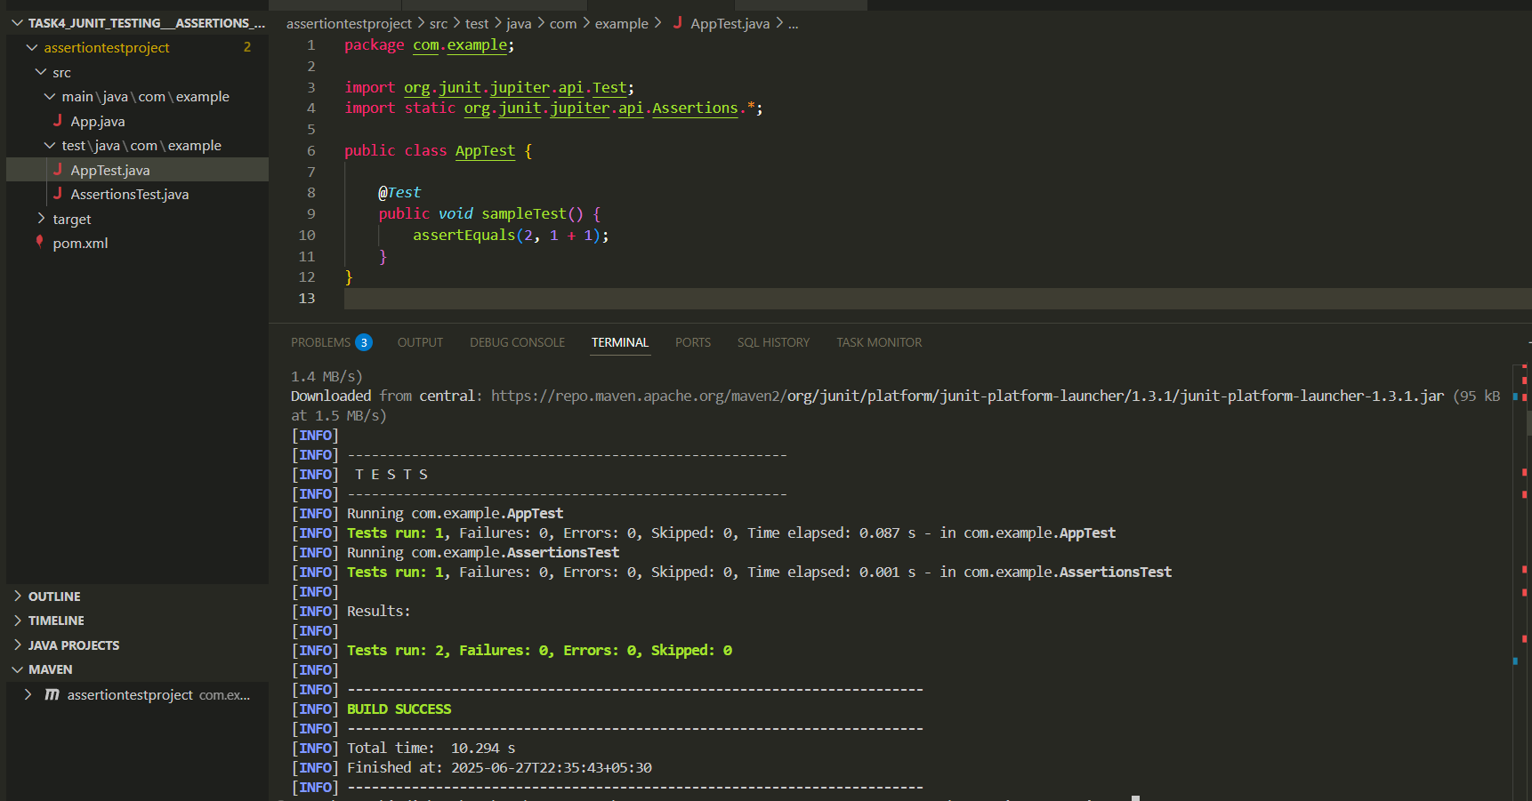

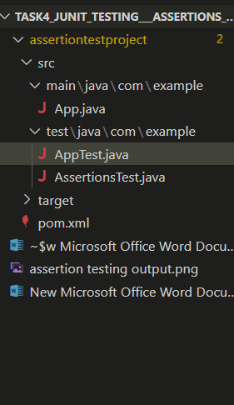

Assertiontest.java  
package com.example;

import org.junit.jupiter.api.Test;

import static org.junit.jupiter.api.Assertions.\*;

public class AppTest {

    @*Test*

    public *void* sampleTest() {

        assertEquals(2, 1 + 1);

    }

}

App.java

package com.example;

public class App {

    public static *void* main(*String*[] *args*) {

        System.out.println("Hello from App.java!");

    }

}

Apptest.java  
package com.example;

import org.junit.jupiter.api.Test;

import static org.junit.jupiter.api.Assertions.\*;

public class AppTest {

    @*Test*

    public *void* sampleTest() {

        assertEquals(2, 1 + 1);

    }

}